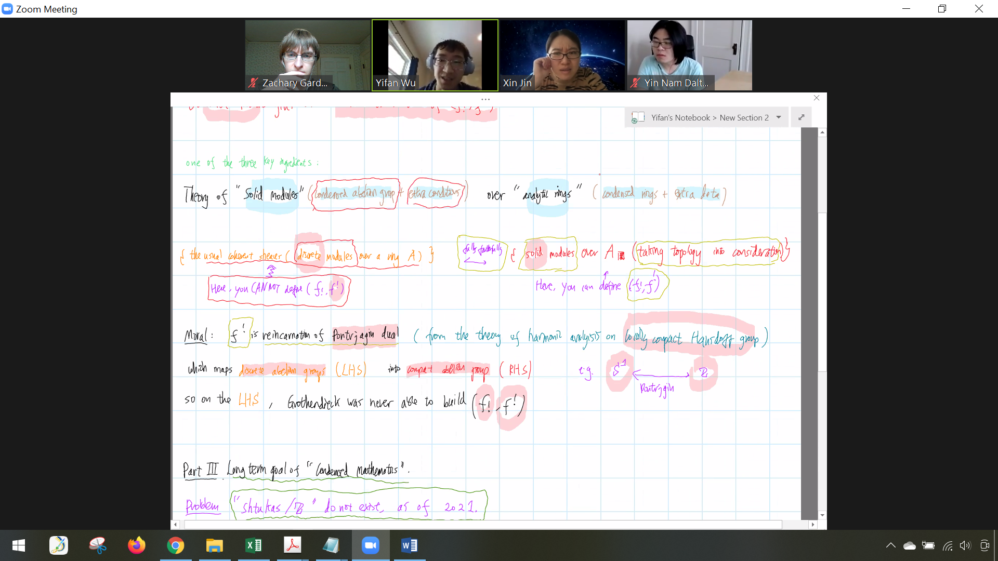

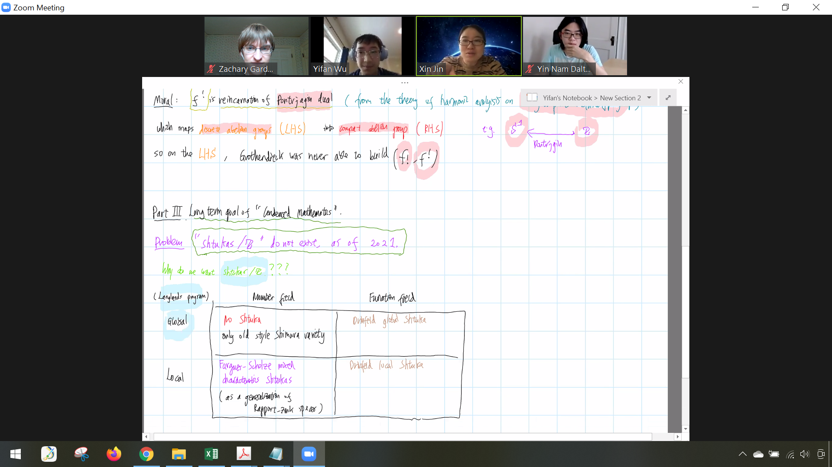

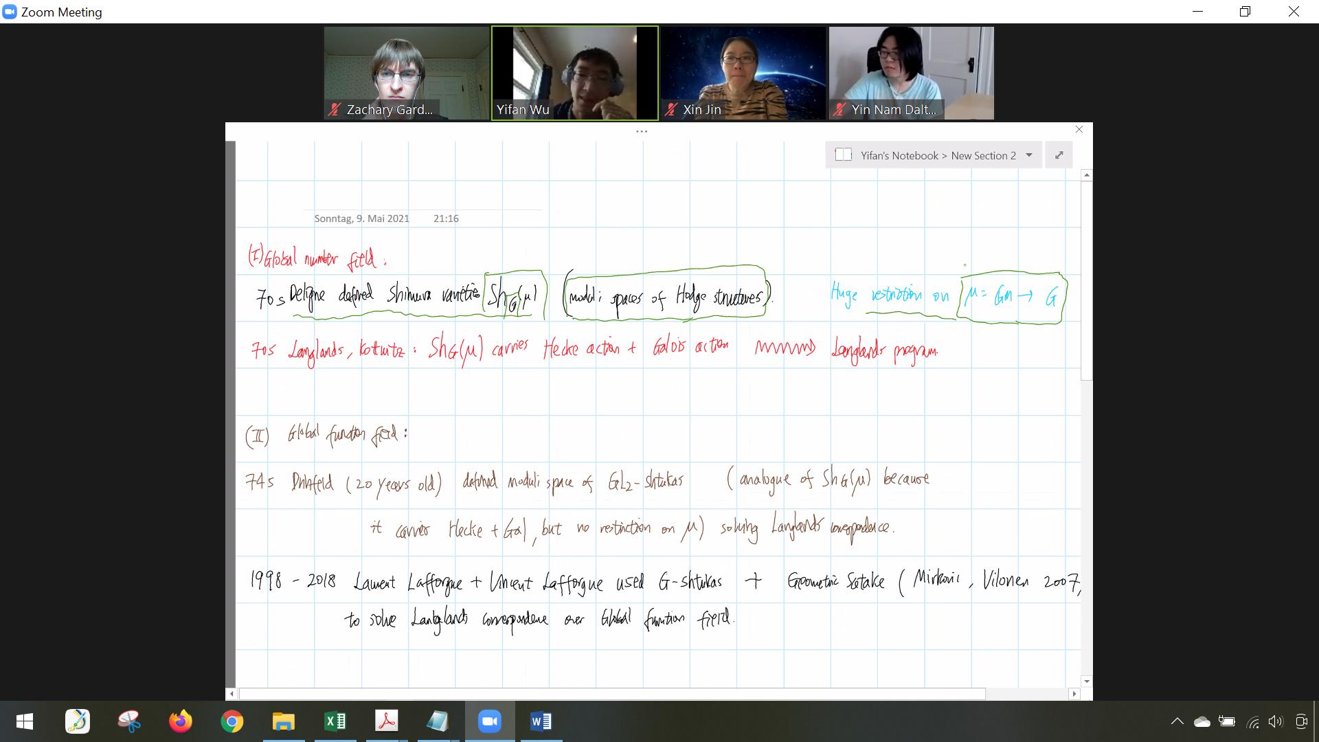

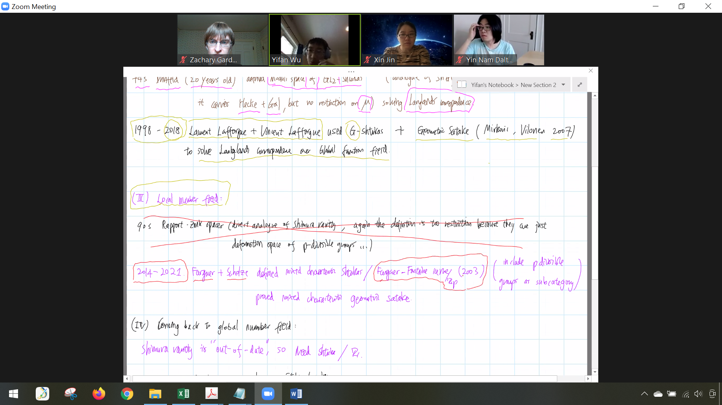

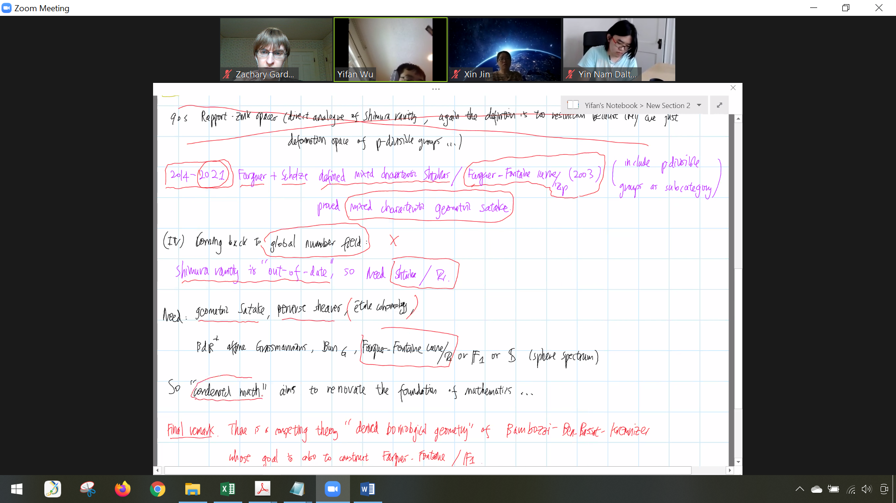

Ginzburg did some characteristic 0 work on geometric Satake following ideas of Drinfeld

Smith-Treumann theory – can conjecturally mix with Scholze’s theory of condensed math, but it’s unknown how (David Treumann at BC)

Key ingredients for generalizing Grothendieck’s 6-functor duality theory

* Theory of solid modules over analytic rings
* Lurie’s \infty-categorical adjunction theory (can’t do this on the triangulated level)
* Huber’s theory of adic spaces